Traveling Waves and Phasor Homework (30 Points)
(jas, Traveling Waves and Phasor HW.docx, 9/20/2025)

Use units and clearly label answers using 3 or 4 significant digits where appropriate. Show your work so that if necessary partial credit can be awarded.
- Determine the wavelength in meters of a 2 GHz electromagnetic wave traveling through a vacuum, meaning u_{p} = c. (2 points.)

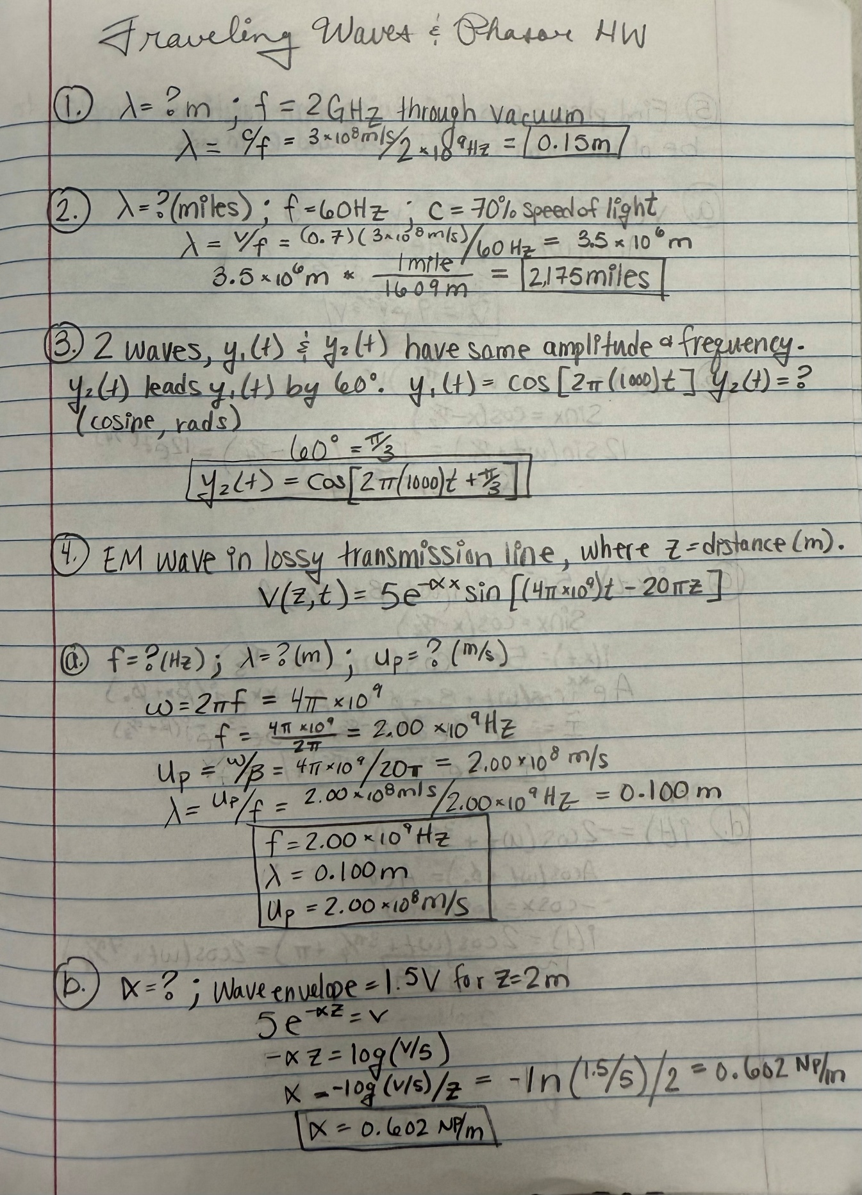

- Determine the wavelength in miles of a 60 Hz electromagnetic wave traveling along a power line at a speed of 70% of the speed of light. (2 points.)



- Two waves y1(t) and y2(t) have the same amplitude and frequency, but y2(t) leads y1(t) by 60°. Given y1(t) = cos[2π(1000)t], write the expression for y2(t) in terms of the cosine function using radians for the argument. (3 points.)



- The voltage of an electromagnetic wave traveling on a lossy transmission line is given as follows where z is the distance in meters from the source:

$$v\left(z,t\right)=5e^{-αz}\sin\left[\left(4π x {10}^{9}\right)t-20πz\right].$$

- Find the frequency in Hz, wavelength in meters (m) and phase velocity of $v\left(z,t\right)$in meters per second (m/s). (2 points each for 6 points total for part a.)



- Find $α$ given that the wave envelope equals 1.5 V for z = 2 meters. (2 points)



- Find the phasor representations of the following time functions. Simplify your results to be of the form $re^{jθ_{r}}$ with r being a positive quantity and $θ_{r}$ in radians. (15 points total.)

- v(t) = 9cos(ωt – π/3) V. (2 points.)
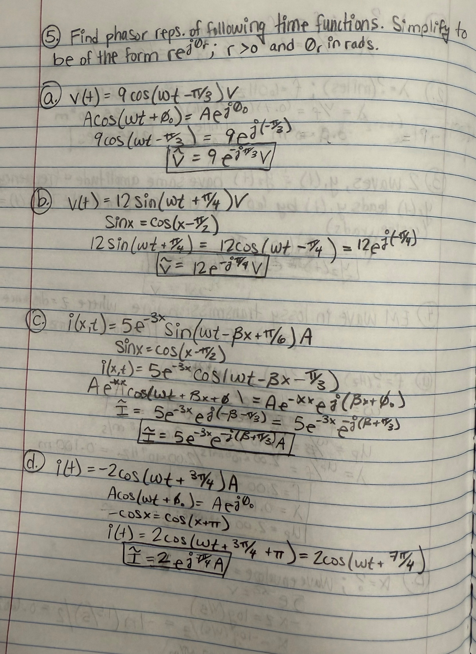

- v(t) = 12sin(ωt + π/4) V. (2 points.)


- i(x, t) = $5e^{-3x}$sin(ωt – βx + π/6) A. (3 points.)


- i(t) = $-2$cos(ωt + 3π/4) A. (4 points.)
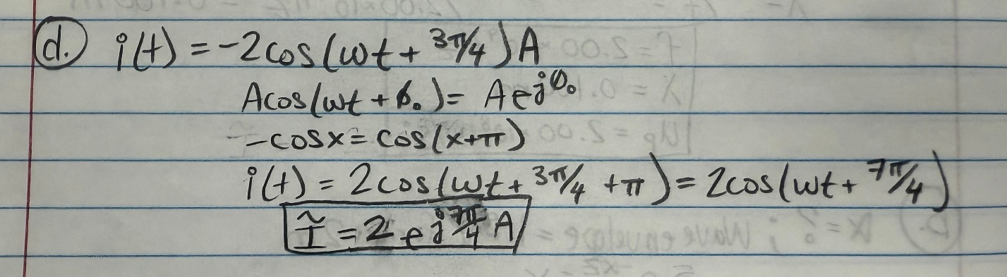

- i(t) = 4sin(ωt + π/3) $+ 3$cos(ωt - π/6) A. (4 points.)

